The True Dress Code Monitor

CPELEC1 – Project

Ryan Joshua Liwag, Anfernee Rapio

Department of Electronics and Communications Engineering

Gokongwei College of Engineering, De La Salle University

Manila, Philippines

*Abstract*— To be able to monitor students within De La Salle University with regards to the dress code policy by creating a program or application which uses image processing and Artificial Neural Network. The output of the program will show and highlight the student that would violate the dress code.

Keywords—Dress code, Artificial Neural Network, image processing, data and results, error

# Introduction

Dress code policy is a rule being implemented among schools and universities with regards to the outfit of the students. With that being said there are also failures on how it is being implemented among the students. For example, other students are still being able to pass through the security even if they are already violating the dress code policy. Also, other security guards fail to implement the policy as they forgot the necessary details and information about it. Other security guards also fail to do it as there are high traffic of students in the entrance therefore giving them a hard time on checking the proper outfit of the students. To be able to properly implement the policy, there must be additional help to the guards for them to monitor it completely. With this problem in the university, we are going to create a program wherein it monitors the outfit among students to see if they are properly implementing the policy. This program also monitors if the student isn’t wearing ID. The program will need to implement the Artificial Neural Network for it to learn to monitor dress codes efficiently.

# Objectives

* To be able to apply Artificial Neural Network on a program or application
* To be able to apply Artificial Neural Network on a specific problem in De La Salle University

# methodology

For the policy to be implemented correctly on De La Salle University, a program would be created to help the security guards of the institution to monitor the outfit of the students. To be able to create the program necessary for the solution of the problem, C programming language is going to be used. Also, for the program to be created and coded properly it is recommended to use operating systems that use Linux For the input of the data, a sample photo of students are needed to scan through if there would be a violation of the policy. For the artificial neural network part, we are going to apply machine intelligence on the program so that it would monitor students with the absence of the user. With these requirements getting accomplished, the program would be efficient enough for it to monitor the outfit of the entering students in the university even if there would be absence of the user.

# Data and Results

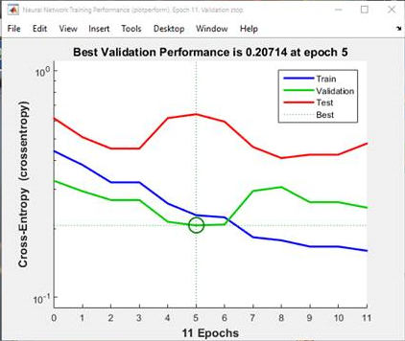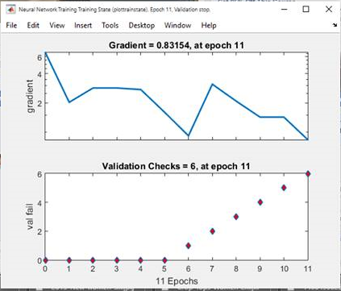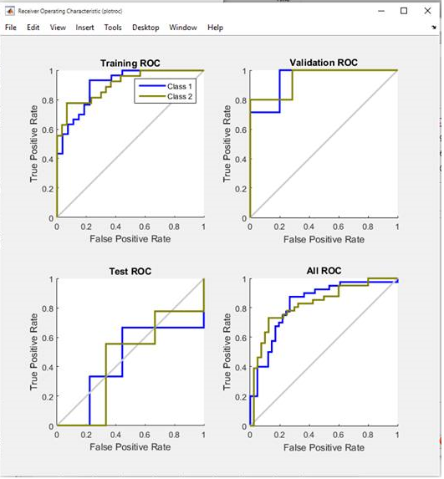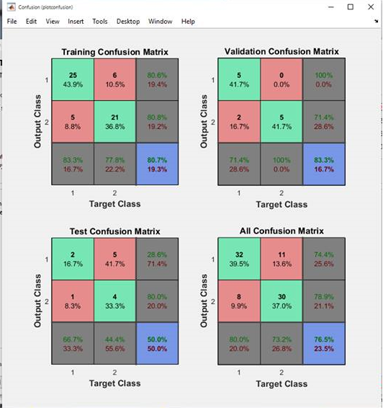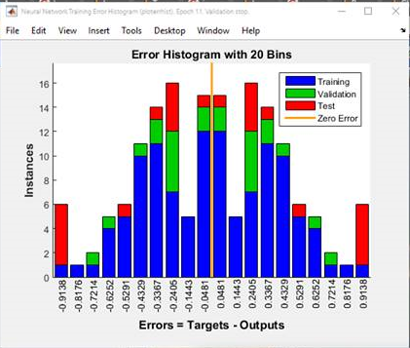

# Analysis and Conclusion

With the data and results giving a detailed information on how the program works, we conclude that it indeed helped the university and its security to implement its policy.

# Bibliography

|  |
| --- |
| [1] |
| [2] |
| [3] |

# Appendix

for C = 1:length(Negative)

File_Negative = Negative(C).name;

I = imread(File_Negative);

I = rgb2gray(I);

% convert to grayscale

P = imresize(I, [64 64]);

% rezie resolution to 64 x 64

N(:,C) = reshape(P,1,[]);

% reshape to form a matrix with 1 column end